18th November 2015


1st Yass Scouts, Cubs Section

Dear Cub Parents,
First off we would like to congratulate James Gray on achieving his Grey Wolf Award which was presented to him by The Regional Commissioner for Riverina Cubs, Mrs “Bub” Johnstone last Wednesday night which took place instead of the normal Cubs night. Braeden Adams from the Scout section received his Australian Scout Medallion, 4 years of hard work and a great example to our Cubs. Well Done to both.
There was lots of adventure for the Cubs tonight with a quick trip to the park and back to the Scout Hall for an exciting obstacle course.
The Cubs started with a CSI style trip to the park to try and find a parrot and what happened to it. Through clues and keen eyes they worked it out and enjoyed seeing birds and playing a who did it game.
Back at the Scout Hall and getting into their Sixes, the Cubs ran through an obstacle course with a waterslide to keep cool. Everyone participated and loved the waterslide with even a couple of the leaders getting wet. The Cubs also took turns having a go on the waterslide, with some Cubs being soaked through, as the parents found out when it was time to go home.
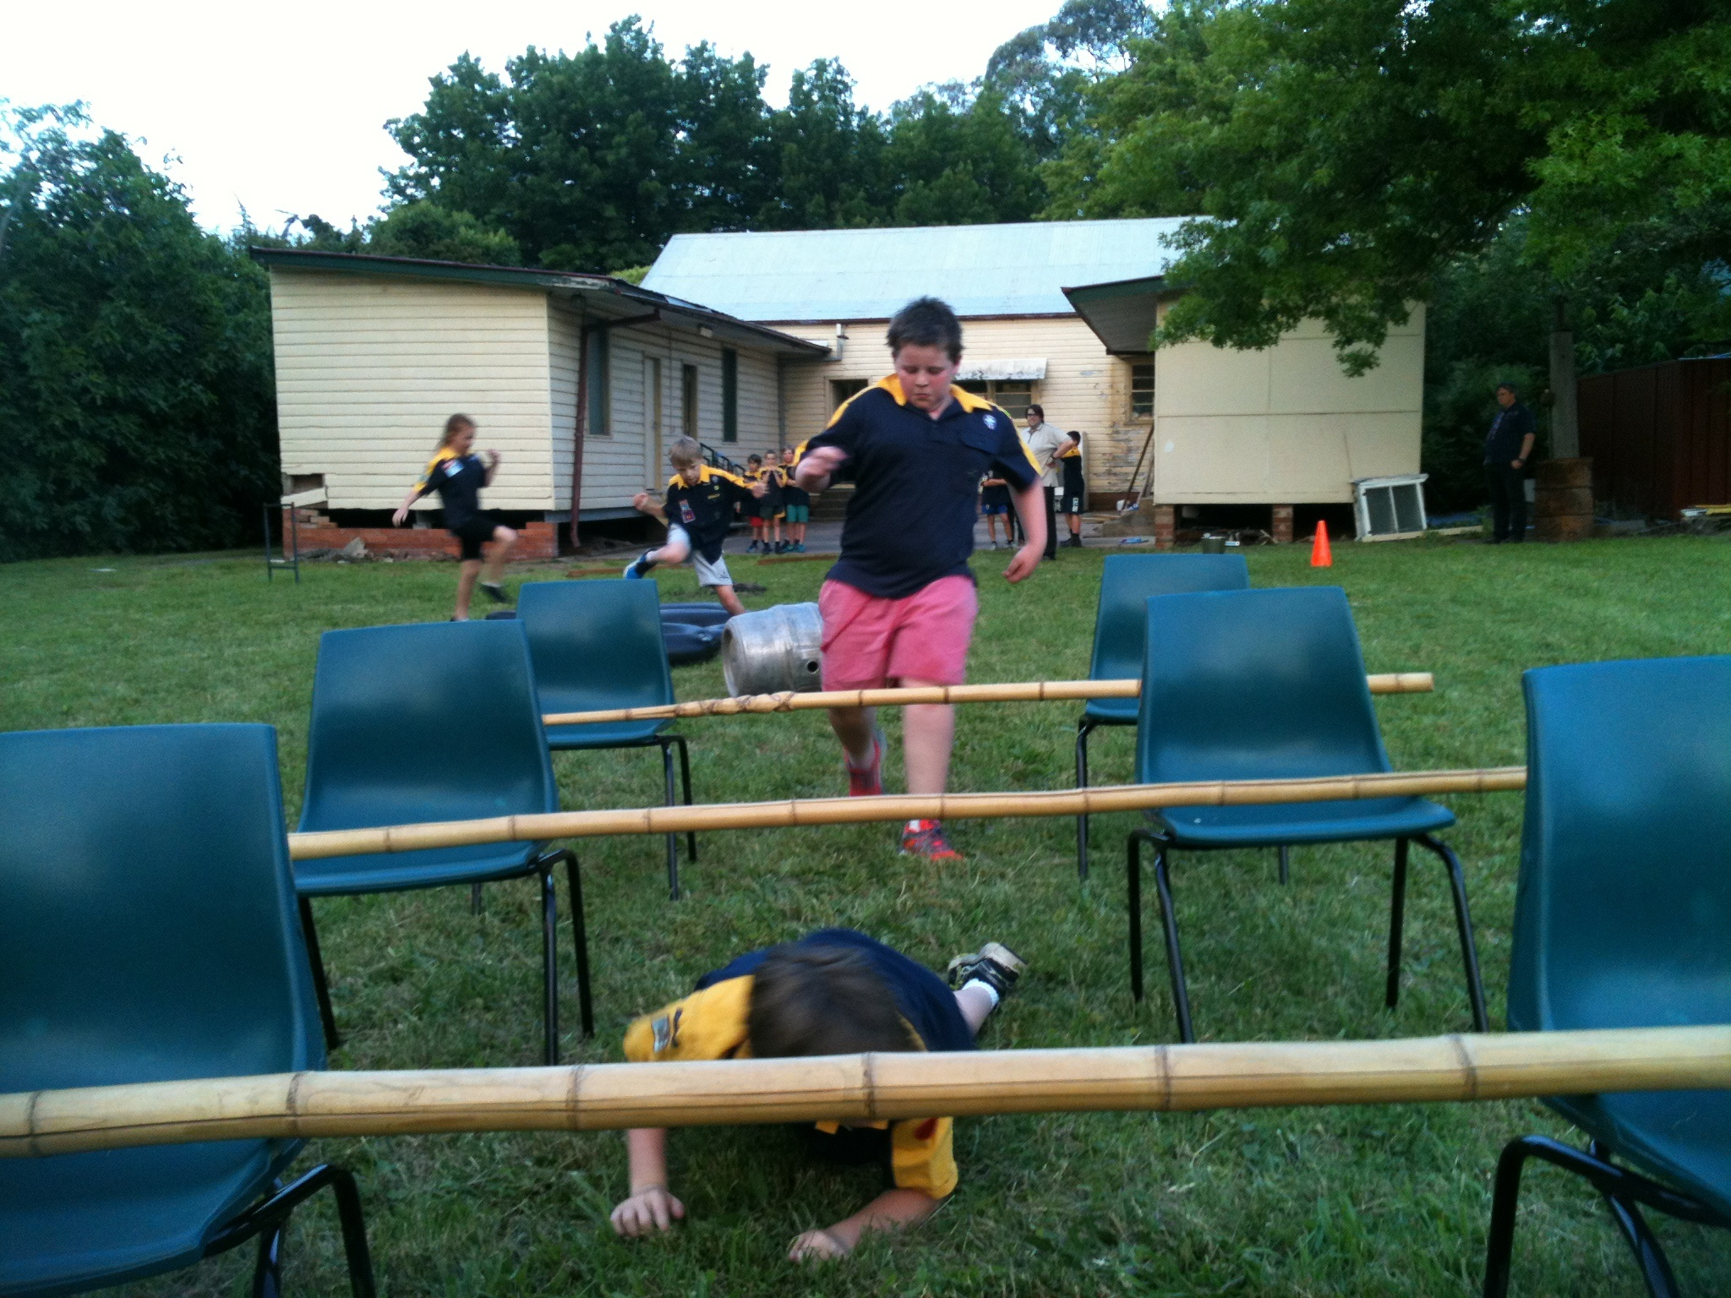
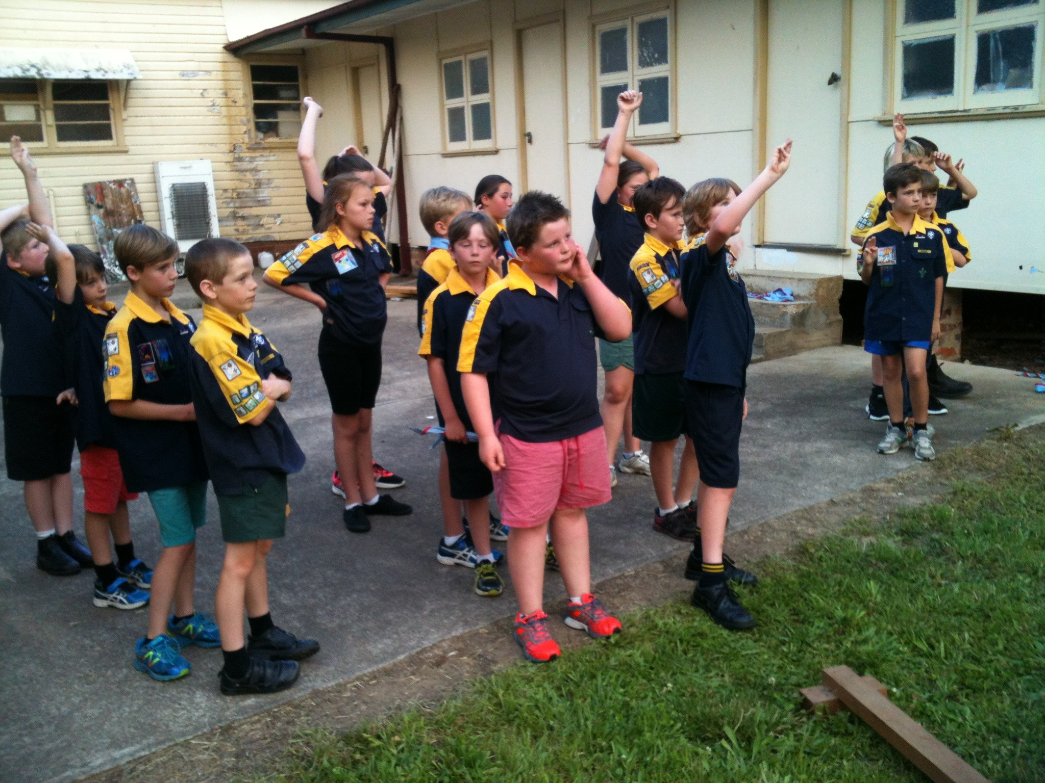
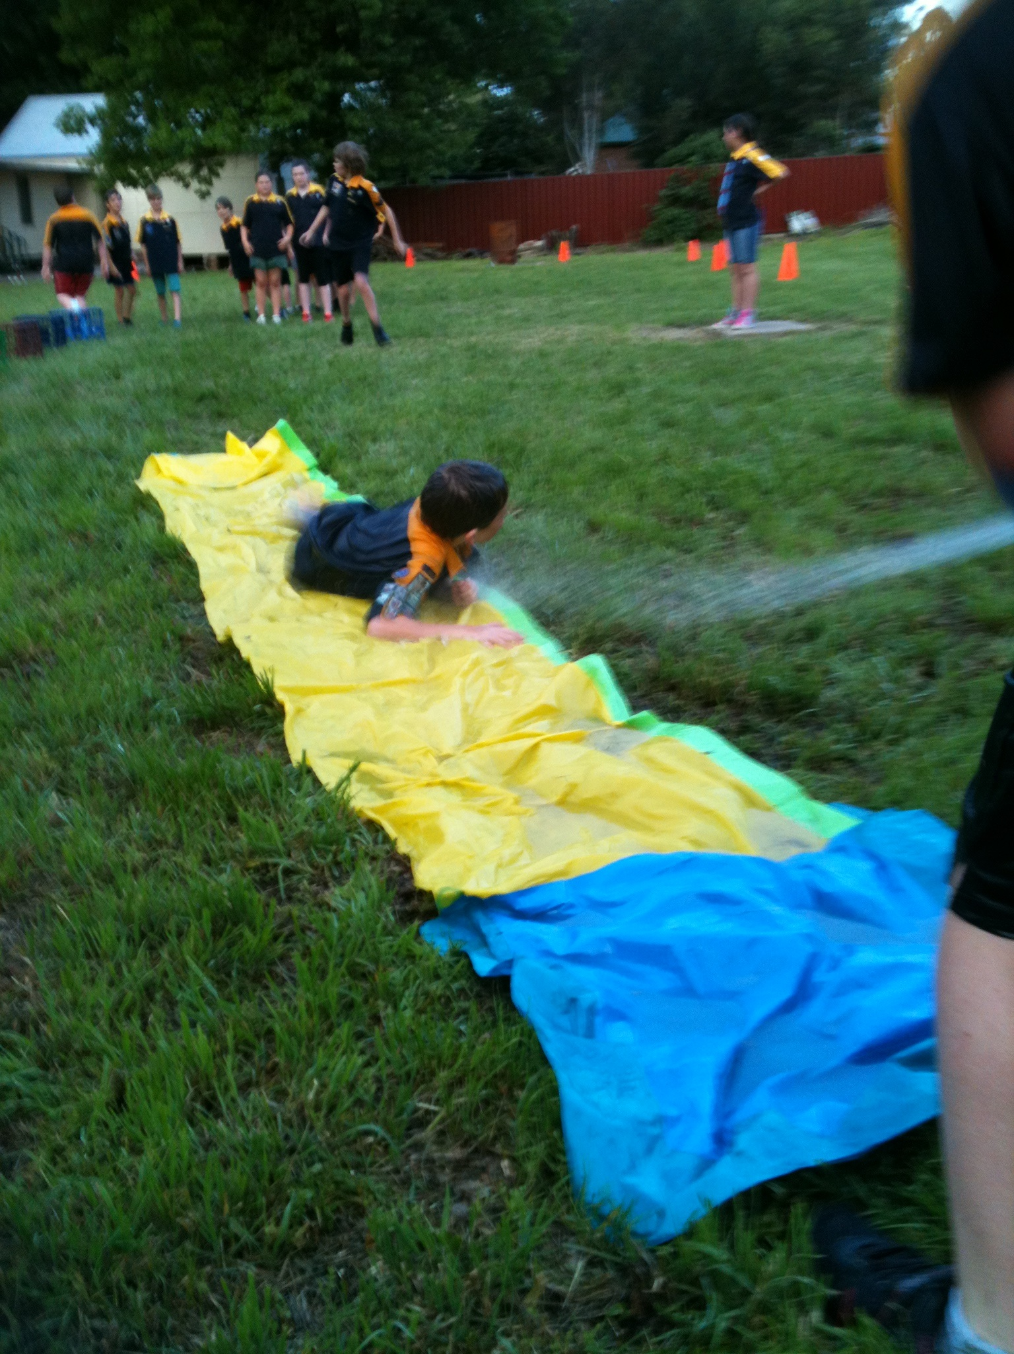
Thanks again to our Cub Leaders Jenny, Don, Joel, Johnno and Michael for a great night and we look forward to next week for more adventure.

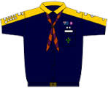



Contact information:
Cub Leaders: Don, Jenny, Joel and Michael
Website: www.1st-yass-scouts.com
Postal: 1st Yass Scouts, PO Box 140, Yass NSW 2582
Scout Hall Address: 234 Comur Street, Yass ( opposite woolworths)

Important Dates:
25th November – Canoeing at Yass river boat ramp, O'Connor Park. (6.30pm). No Uniform required, water suitable clothing ie. Swimmers underneath polo shirt and shorts.
2nd December – Treasure Island (6.30pm) Scout Hall
5th - 6th December – Cub and Scout Camp “Cowboys and Indians”, Cottermouth Campsite Cotter Dam, Cotter Road via Weston Creek A.C.T. (8.45am Scout hall to leave to head to camp)
NOTE: letters sent home on gear needed for the camp.

