7th October 2015


1st Yass Scouts, Cubs Section

Dear Cub Parents,
Welcome back to Term 4 and we all hope everyone enjoyed their school holidays and the countdown to Christmas has begun. The cubs eased back into the new term with a special Pack council meeting and some music.
The Sixers and Seconders we invited to put forward ideas for the coming years activities and the badges they would like to pursue as a Pack.
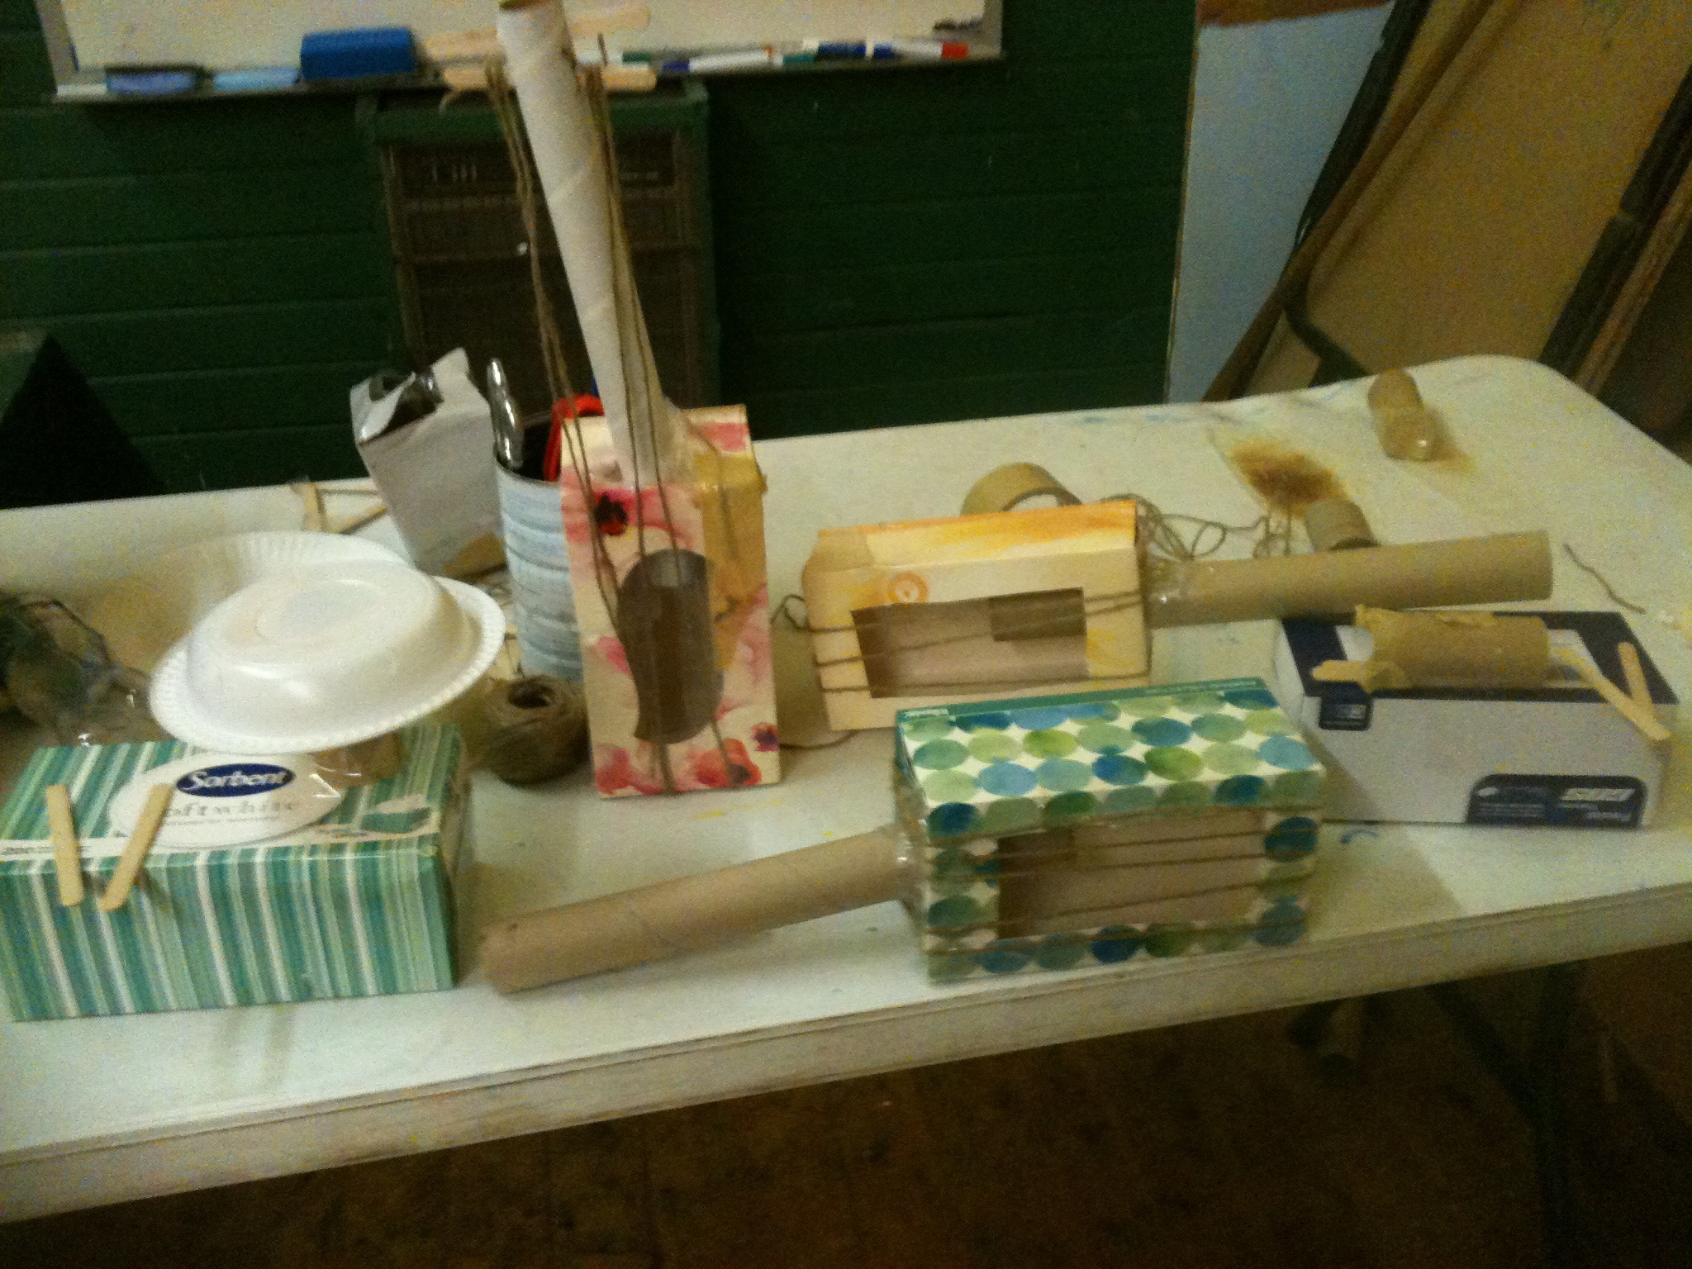
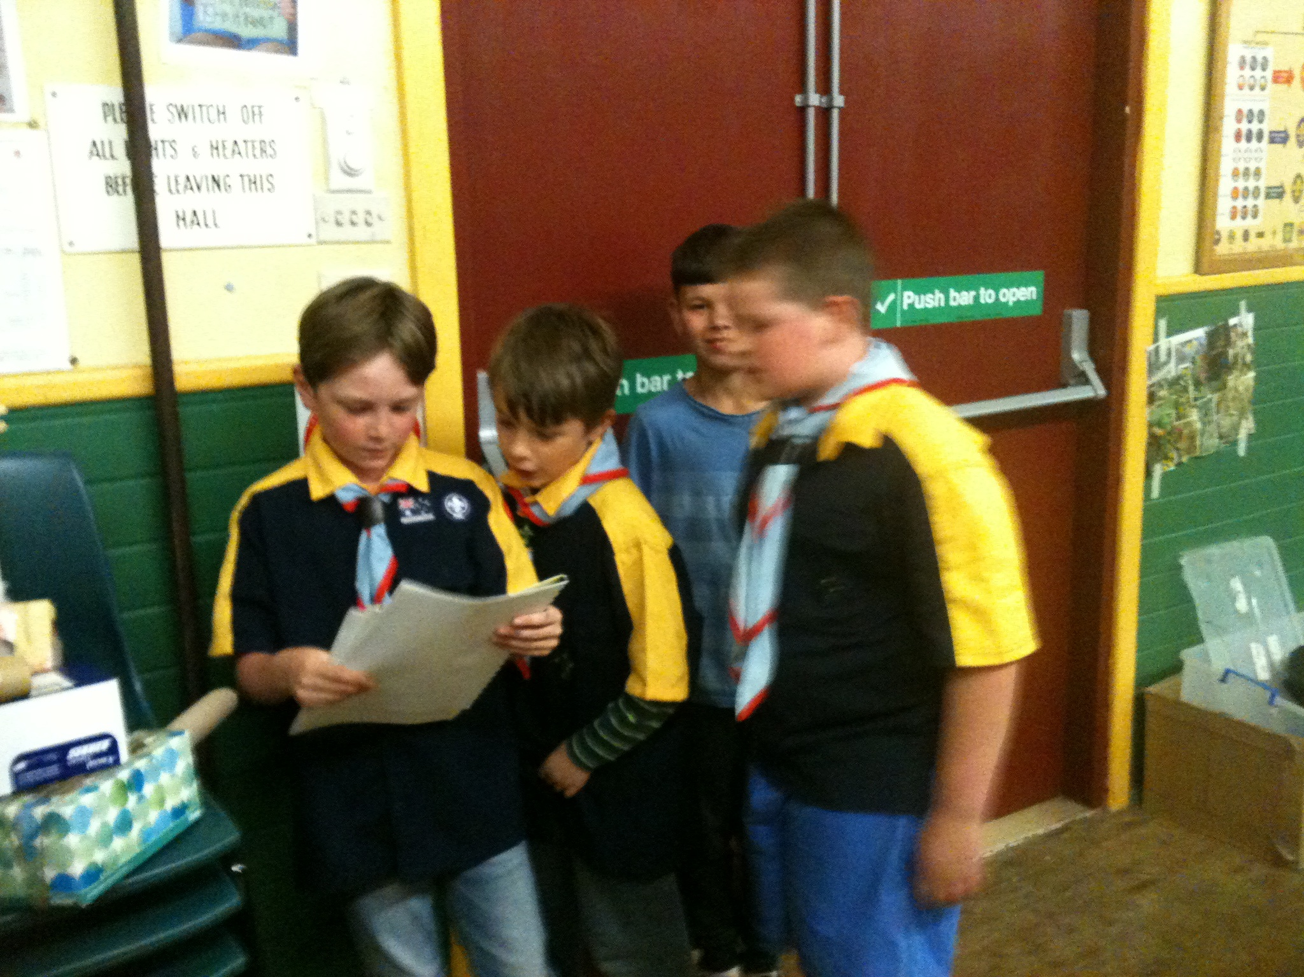
The rest of the Cubs enjoyed anight of music with Michael taking a group for craft instruments with a performance at the end with some drums and guitars. Joel also took a group who had to learn 3 camp fire songs and perform them at the end of the time, they did very well.

Thanks again to our Cub Leaders Jenny, Don, Joel, Johnno and Michael for a great night and we look forward to next week for more adventure.

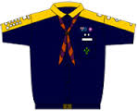



Contact information:
Cub Leaders: Don, Jenny, Joel and Michael
Website: www.1st-yass-scouts.com
Postal: 1st Yass Scouts, PO Box 140, Yass NSW 2582
Scout Hall Address: 234 Comur Street, Yass ( opposite woolworths)

Important Dates:
14th October 2015 – On the Trail, Out of Hall night (6.30pm).
18th October 2015 – National Zoo and Aquarium Trip (10am).
21st October 2015 – Animals in Nature (6.30pm)

